Is That Gay?
Children & Families

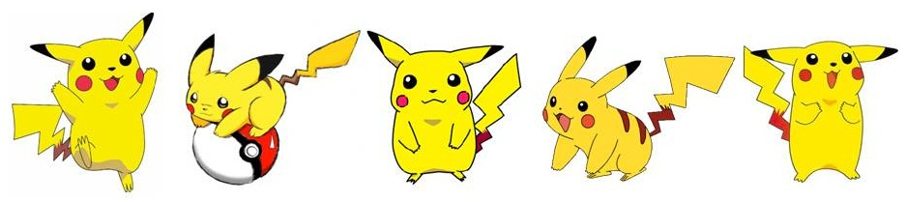

Slide1
Gay Pride month is in full swing, and its celebration of diversity and creativity in how we perform gender has gotten me thinking about the ways our lives can be shaped by the roles and rules we’re taught for how to be women or men — and it starts when we’re very young. How do we help our children deal with these issues? The exploration of the conventional and cultural expectations of young boys, in particular, is an ongoing dialogue in the field of psychology.
One of the important voices in the field is the very talented child psychologist Dr. Tony Rao. He and I spoke about many of these issues in a public dialogue at the East Side Institute a couple of years ago. His book, The Way of Boys: Raising Healthy Boys in a Challenging and Complex World, gives wonderful support to parents, teachers (and clinicians) who want to create environments that allow boys to be who and how they are, without turning their every hyperactive move into a pathology. (On June 29, the Institute will show a video of that discussion as part of a webinar entitled “Breakthroughs in Child Psychology.” If you’re interested in participating, you can contact mfridley@eastsideinstitute.org. And you can have a look at the video here: http://vimeo.com/18562495.
Another seminal voice in this area is Dr. William Pollack, the Harvard Medical School researcher who for over two decades has studied the emotional turmoil — the confusion, the loneliness and sadness — that boys can experience. This work is documented in his book Real Boys: Rescuing Our Sons from the Myths of Boyhood, which focuses on how to help boys develop more confidence by challenging expectations of masculinity. Do read it.
As a social therapist, my contribution to this dialogue has emerged from our multi-family groups, in one of which I work with five nine- and ten-year-old boys. Along with their families, we’re exploring how to deal with the ways they feel unsure, conflicted and perplexed about how to be a boy. They often feel enormous pressure and a deep need to turn off their emotionality, toughen up, to act like things don’t bother them, and never express their caring for each other. And at all costs resist having a play date with a girl! (What would the other boys think?) These cultural standards of maleness are the price of acceptance by other kids (and sometimes even their parents).

gay pride4
I have been working with these five boys for over two years. In their school settings the boys find social relationship to be quite challenging. Some have diagnoses, some don’t. They’re quite different from one another, but are all energetic, creative and playful. One boy, Tom, has a particularly difficult time joining the group conversations and performances. He often likes to play with a small set of toys I keep on my desk — puppets, miniature paintings, plastic animals — and once in awhile he’ll join our group activities. We love him and the boys are kind to him — they always invite him in, and accept his difficulties.
One afternoon, in a children-only session, I introduced the idea that we were going to play with how we talk to each other. One child asked if there were any rules. I said yes, the rule is that we are not allowed to make any sense at all.
They became very animated and excited, and began running around the room. One boy asked if I was included in that rule. I said that indeed I was, but now we were breaking the rule — we were making sense! “Oh, no,” he said, and then ran away, laughing. Along with my steadfast co-therapist, Lew Steinhardt, I ran around the room with them.
We began a series of games — speaking nonsense and gibberish, using words “incorrectly.” It was silly. The children were incredibly joyful. I felt joyful with them, and laughed through most of the session. The children created movement, ran all around, and rolled on the floor as they played with the activity of communicating in a new way. We thoroughly enjoyed doing this together. How interesting, I thought. I had not seen them so joyful and so much of a group in awhile, if ever. As we played, we were making up new ways to be together, which were not coherent with the rules and roles for children and adults. The boys became very affectionate with each other. I had not seen them do this so openly before.
Near the end of the session I asked them how the group was doing. They became very sheepish and put their heads down. I was perplexed, and asked them what was going on. One boy, Michael, said it was embarrassing. I asked him what was embarrassing. No answer. Then Michael said the group felt close today. “Close. Yes,” I agreed. Then I decided to push this issue even further.
“I would even say that you really love each other,” I said. They were silent.
Tom, the ten-year-old who has difficulty being a part of the group, said, “Yuck that’s gay.”
Another boy asked, “Is that gay?
I thought about how I wanted to answer. What would be most valuable for them, given the struggles they have with their emotionality ?
I said, “Yes. It is gay to love whomever you want to.”
Tom said, “Gay is disgusting.” The other boys said nothing, and the session ended.
The following week, Tom spoke first, and said, “Christine, I have something to tell you.”
“Great,” I replied. “Tell all of us.”
He said, “I am now in a gay relationship.”
“Really?” I said. I noticed that the boys didn’t giggle. They were curious about what Tom was saying.
Michael asked, “Who are you in a relationship with?”
“Pikachu,” he answered. (For the uninitiated, Pikachu is a well-known character in the world of Pokémon.)
“Congratulations!” I said. “I’m happy for you. What do you love about Pikachu?”
“He’s yellow,” Tom said. Everyone laughed.

pikachu
“I get it,” I said. “I think I get it. I love yellow, too.” Everyone laughed again.
Another boy in the group calmly said, “You can’t be in love with a fictional character.”
Tom asked me, “What do you think about this?” I assured him that a lot of people are in love with fictional characters. Lew and I laughed.
Tom asked again, “So Christine, how do you feel about this?” I said that I was very happy for him and Pikachu. The boys smiled and nodded. They nonchalantly began to play some floor games. Tom joined them for the remainder of the group play.

