The Overprotected Kid
A preoccupation with safety has stripped childhood of independence, risk taking, and discovery—without making it safer. A new kind of playground points to a better solution.

Hanna Rosin
MARCH 19, 2014
- Facebook
- Twitter
- LinkedIn
- Google+
- Email
- 725 Comments
A trio of boys tramps along the length of a wooden fence, back and forth, shouting like carnival barkers. “The Land! It opens in half an hour.” Down a path and across a grassy square, 5-year-old Dylan can hear them through the window of his nana’s front room. He tries to figure out what half an hour is and whether he can wait that long. When the heavy gate finally swings open, Dylan, the boys, and about a dozen other children race directly to their favorite spots, although it’s hard to see how they navigate so expertly amid the chaos. “Is this a junkyard?” asks my 5-year-old son, Gideon, who has come with me to visit. “Not exactly,” I tell him, although it’s inspired by one. The Land is a playground that takes up nearly an acre at the far end of a quiet housing development in North Wales. It’s only two years old but has no marks of newness and could just as well have been here for decades. The ground is muddy in spots and, at one end, slopes down steeply to a creek where a big, faded plastic boat that most people would have thrown away is wedged into the bank. The center of the playground is dominated by a high pile of tires that is growing ever smaller as a redheaded girl and her friend roll them down the hill and into the creek. “Why are you rolling tires into the water?” my son asks. “Because we are,” the girl replies.
It’s still morning, but someone has already started a fire in the tin drum in the corner, perhaps because it’s late fall and wet-cold, or more likely because the kids here love to start fires. Three boys lounge in the only unbroken chairs around it; they are the oldest ones here, so no one complains. One of them turns on the radio—Shaggy is playing (Honey came in and she caught me red-handed, creeping with the girl next door)—as the others feel in their pockets to make sure the candy bars and soda cans are still there. Nearby, a couple of boys are doing mad flips on a stack of filthy mattresses, which makes a fine trampoline. At the other end of the playground, a dozen or so of the younger kids dart in and out of large structures made up of wooden pallets stacked on top of one another. Occasionally a group knocks down a few pallets—just for the fun of it, or to build some new kind of slide or fort or unnamed structure. Come tomorrow and the Land might have a whole new topography.
Other than some walls lit up with graffiti, there are no bright colors, or anything else that belongs to the usual playground landscape: no shiny metal slide topped by a red steering wheel or a tic-tac-toe board; no yellow seesaw with a central ballast to make sure no one falls off; no rubber bucket swing for babies. There is, however, a frayed rope swing that carries you over the creek and deposits you on the other side, if you can make it that far (otherwise it deposits you in the creek). The actual children’s toys (a tiny stuffed elephant, a soiled Winnie the Pooh) are ignored, one facedown in the mud, the other sitting behind a green plastic chair. On this day, the kids seem excited by a walker that was donated by one of the elderly neighbors and is repurposed, at different moments, as a scooter, a jail cell, and a gymnastics bar.
An excerpt from The Land, a documentary by Vermont-based filmmaker Erin Davis
The Land is an “adventure playground,” although that term is maybe a little too reminiscent of theme parks to capture the vibe. In the U.K., such playgrounds arose and became popular in the 1940s, as a result of the efforts of Lady Marjory Allen of Hurtwood, a landscape architect and children’s advocate. Allen was disappointed by what she described in a documentary as “asphalt square” playgrounds with “a few pieces of mechanical equipment.” She wanted to design playgrounds with loose parts that kids could move around and manipulate, to create their own makeshift structures. But more important, she wanted to encourage a “free and permissive atmosphere” with as little adult supervision as possible. The idea was that kids should face what to them seem like “really dangerous risks” and then conquer them alone. That, she said, is what builds self-confidence and courage.
related story

How to Land Your Kid in Therapy
"Back in graduate school, the clinical focus had always been on how the lack of parental attunement affects the child. It never occurred to any of us to ask, what if the parents are too attuned? What happens to those kids?"
Read the full story by Lori Gottlieb in the July/August 2011 issue
The playgrounds were novel, but they were in tune with the cultural expectations of London in the aftermath of World War II. Children who might grow up to fight wars were not shielded from danger; they were expected to meet it with assertiveness and even bravado. Today, these playgrounds are so out of sync with affluent and middle-class parenting norms that when I showed fellow parents back home a video of kids crouched in the dark lighting fires, the most common sentence I heard from them was “This is insane.” (Working-class parents hold at least some of the same ideals, but are generally less controlling—out of necessity, and maybe greater respect for toughness.) That might explain why there are so few adventure playgrounds left around the world, and why a newly established one, such as the Land, feels like an act of defiance.
If a 10-year-old lit a fire at an American playground, someone would call the police and the kid would be taken for counseling. At the Land, spontaneous fires are a frequent occurrence. The park is staffed by professionally trained “playworkers,” who keep a close eye on the kids but don’t intervene all that much. Claire Griffiths, the manager of the Land, describes her job as “loitering with intent.” Although the playworkers almost never stop the kids from what they’re doing, before the playground had even opened they’d filled binders with “risk benefits assessments” for nearly every activity. (In the two years since it opened, no one has been injured outside of the occasional scraped knee.) Here’s the list of benefits for fire: “It can be a social experience to sit around with friends, make friends, to sing songs to dance around, to stare at, it can be a co-operative experience where everyone has jobs. It can be something to experiment with, to take risks, to test its properties, its heat, its power, to re-live our evolutionary past.” The risks? “Burns from fire or fire pit” and “children accidentally burning each other with flaming cardboard or wood.” In this case, the benefits win, because a playworker is always nearby, watching for impending accidents but otherwise letting the children figure out lessons about fire on their own.
Kids once took special pride in “knowing how to get places” alone, and in finding shortcuts adults normally wouldn’t use.
“I’m gonna put this cardboard box in the fire,” one of the boys says.
“You know that will make a lot of smoke,” says Griffiths.
“Where there’s smoke, there’s fire,” he answers, and in goes the box. Smoke instantly fills the air and burns our eyes. The other boys sitting around the fire cough, duck their heads, and curse him out. In my playground set, we would call this “natural consequences,” although we rarely have the nerve to let even much tamer scenarios than this one play out. By contrast, the custom at the Land is for parents not to intervene. In fact, it’s for parents not to come at all. The dozens of kids who passed through the playground on the day I visited came and went on their own. In seven hours, aside from Griffiths and the other playworkers, I saw only two adults: Dylan’s nana, who walked him over because he’s only 5, and Steve Hughes, who runs a local fishing-tackle shop and came by to lend some tools.
Griffiths started selling local families on the proposed playground in 2006. She talked about the health and developmental benefits of freer outdoor play, and explained that the playground would look messy but be fenced in. But mostly she made an appeal rooted in nostalgia. She explained some of the things kids might be able to do and then asked the parents to remember their own childhoods. “Ahh, did you never used to do that?” she would ask. This is how she would win them over. Hughes moved to the neighborhood after the Land was already open, but when he stopped by, I asked how he would have answered that question. “When I was a kid, we didn’t have all the rules about health and safety,” he said. “I used to go swimming in the Dee, which is one of the most dangerous rivers around. If my parents had found out, they would have grounded me for life. But back then we would get up to all sorts of mischief.”
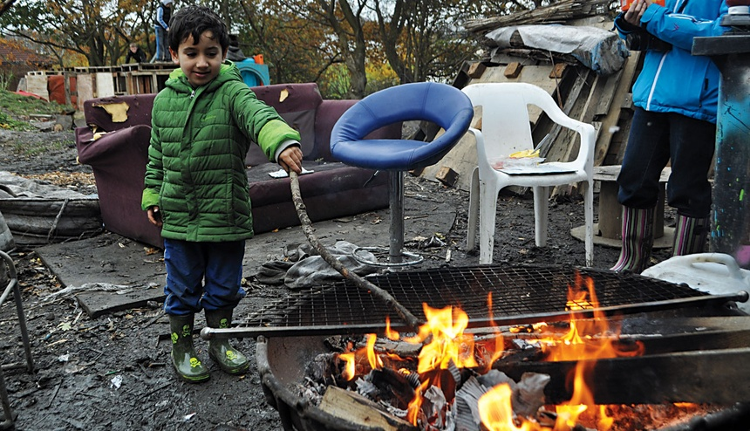The author’s 5-year-old son, Gideon, playing at the Land playground in North Wales. (Hanna Rosin)
Like most parents my age, I have memories of childhood so different from the way my children are growing up that sometimes I think I might be making them up, or at least exaggerating them. I grew up on a block of nearly identical six-story apartment buildings in Queens, New York. In my elementary-school years, my friends and I spent a lot of afternoons playing cops and robbers in two interconnected apartment garages, after we discovered a door between them that we could pry open. Once, when I was about 9, my friend Kim and I “locked” a bunch of younger kids in an imaginary jail behind a low gate. Then Kim and I got hungry and walked over to Alba’s pizzeria a few blocks away and forgot all about them. When we got back an hour later, they were still standing in the same spot. They never hopped over the gate, even though they easily could have; their parents never came looking for them, and no one expected them to. A couple of them were pretty upset, but back then, the code between kids ruled. We’d told them they were in jail, so they stayed in jail until we let them out. A parent’s opinion on their term of incarceration would have been irrelevant.
I used to puzzle over a particular statistic that routinely comes up in articles about time use: even though women work vastly more hours now than they did in the 1970s, mothers—and fathers—of all income levels spend much more time with their children than they used to. This seemed impossible to me until recently, when I began to think about my own life. My mother didn’t work all that much when I was younger, but she didn’t spend vast amounts of time with me, either. She didn’t arrange my playdates or drive me to swimming lessons or introduce me to cool music she liked. On weekdays after school she just expected me to show up for dinner; on weekends I barely saw her at all. I, on the other hand, might easily spend every waking Saturday hour with one if not all three of my children, taking one to a soccer game, the second to a theater program, the third to a friend’s house, or just hanging out with them at home. When my daughter was about 10, my husband suddenly realized that in her whole life, she had probably not spent more than 10 minutes unsupervised by an adult. Not 10 minutes in 10 years.
It’s hard to absorb how much childhood norms have shifted in just one generation. Actions that would have been considered paranoid in the ’70s—walking third-graders to school, forbidding your kid to play ball in the street, going down the slide with your child in your lap—are now routine. In fact, they are the markers of good, responsible parenting. One very thorough study of “children’s independent mobility,” conducted in urban, suburban, and rural neighborhoods in the U.K., shows that in 1971, 80 percent of third-graders walked to school alone. By 1990, that measure had dropped to 9 percent, and now it’s even lower. When you ask parents why they are more protective than their parents were, they might answer that the world is more dangerous than it was when they were growing up. But this isn’t true, or at least not in the way that we think. For example, parents now routinely tell their children never to talk to strangers, even though all available evidence suggests that children have about the same (very slim) chance of being abducted by a stranger as they did a generation ago. Maybe the real question is, how did these fears come to have such a hold over us? And what have our children lost—and gained—as we’ve succumbed to them?
related story

Why Parents Need to Let Their Kids Fail
"Year after year, my 'best' students—the ones who are happiest and successful in their lives—are the students who were allowed to fail, held responsible for missteps, and challenged to be the best people they could be in the face of their mistakes."
Read the full January 2013 story by Jessica Lahey
In 1978, a toddler named Frank Nelson made his way to the top of a 12-foot slide in Hamlin Park in Chicago, with his mother, Debra, a few steps behind him. The structure, installed three years earlier, was known as a “tornado slide” because it twisted on the way down, but the boy never made it that far. He fell through the gap between the handrail and the steps and landed on his head on the asphalt. A year later, his parents sued the Chicago Park District and the two companies that had manufactured and installed the slide. Frank had fractured his skull in the fall and suffered permanent brain damage. He was paralyzed on his left side and had speech and vision problems. His attorneys noted that he was forced to wear a helmet all the time to protect his fragile skull.
The Nelsons’ was one of a number of lawsuits of that era that fueled a backlash against potentially dangerous playground equipment. Theodora Briggs Sweeney, a consumer advocate and safety consultant from John Carroll University, near Cleveland, testified at dozens of trials and became a public crusader for playground reform. “The name of the playground game will continue to be Russian roulette, with the child as unsuspecting victim,” Sweeney wrote in a 1979 paper published in Pediatrics. She was concerned about many things—the heights of slides, the space between railings, the danger of loose S-shaped hooks holding parts together—but what she worried about most was asphalt and dirt. In her paper, Sweeney declared that lab simulations showed children could die from a fall of as little as a foot if their head hit asphalt, or three feet if their head hit dirt.
A federal-government report published around that time found that tens of thousands of children were turning up in the emergency room each year because of playground accidents. As a result, the U.S. Consumer Product Safety Commission in 1981 published the first “Handbook for Public Playground Safety,” a short set of general guidelines—the word guidelineswas in bold, to distinguish the contents from requirements—that should govern the equipment. For example, no component of any equipment should form angles or openings that could trap any part of a child’s body, especially the head.
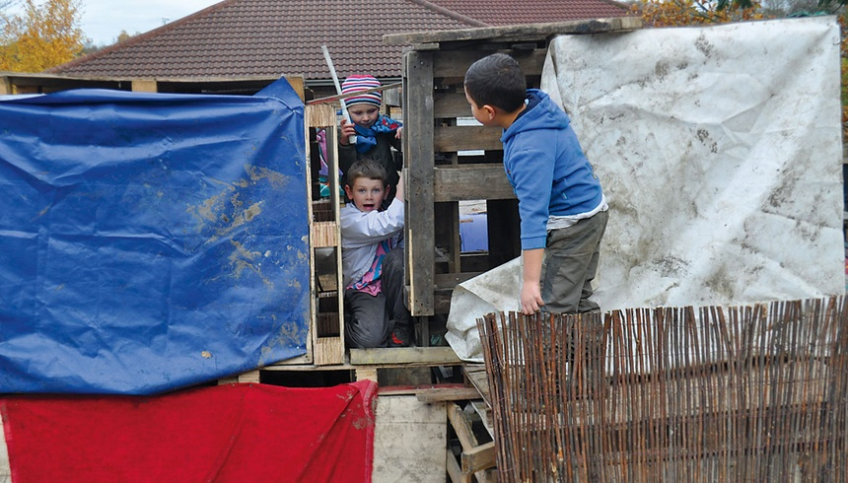By overcoming fears, children achieve a measure of independence, and may inoculate themselves from adult phobias. (Hanna Rosin)
To turn up the pressure, Sweeney and a fellow consultant on playground safety, Joe Frost, began cataloguing the horrors that befell children at playgrounds. Between them, they had testified in almost 200 cases and could detail gruesome specifics—several kids who had gotten their heads trapped or crushed by merry-go-rounds; one who was hanged by a jump rope attached to a deck railing; one who was killed by a motorcycle that crashed into an unfenced playground; one who fell while playing football on rocky ground. In a paper they wrote together, Sweeney and Frost called for “immediate inspection” of all equipment that had been installed before 1981, and the removal of anything faulty. They also called for playgrounds nationwide to incorporate rubber flooring in crucial areas.
In January 1985, the Chicago Park District settled the suit with the Nelsons. Frank Nelson was guaranteed a minimum of $9.5 million. Maurice Thominet, the chief engineer for the Park District, told the Chicago Tribunethat the city would have to “take a cold, hard look at all of our equipment” and likely remove all the tornado slides and some other structures. At the time, a reader wrote to the paper:
Do accidents happen anymore? …
Can a mother take the risk of taking her young child up to the top of a tornado slide, with every good intention, and have an accident?
Who is responsible for a child in a park, the park district or the parent? … Swings hit 1-year-old children in the head, I’m sure with dire consequences in some instances. Do we eliminate swings?
But these proved to be musings from a dying age. Around the time the Nelson settlement became public, park departments all over the country began removing equipment newly considered dangerous, partly because they could not afford to be sued, especially now that a government handbook could be used by litigants as proof of standards that parks were failing to meet. In anticipation of lawsuits, insurance premiums skyrocketed. As the Tribune reader had intuited, the cultural understanding of acceptable risk began to shift, such that any known risk became nearly synonymous with hazard.
Over the years, the official consumer-product handbook has gone through several revisions; it is now supplemented by a set of technical guidelines for manufacturers. More and more, the standards are set by engineers and technical experts and lawyers, with little meaningful input from “people who know anything about children’s play,” says William Weisz, a design consultant who has sat on several committees overseeing changes to the guidelines. The handbook includes specific prescriptions for the exact heights, slopes, and other angles of nearly every piece of equipment. Rubber flooring or wood chips are virtually required; grass and dirt are “not considered protective surfacing because wear and environmental factors can reduce their shock absorbing effectiveness.”
“Reasonable risks are essential for children’s healthy development,” says Joe Frost, an influential safety crusader.
It is no longer easy to find a playground that has an element of surprise, no matter how far you travel. Kids can find the same slides at the same heights and angles as the ones in their own neighborhood, with many of the same accessories. I live in Washington, D.C., near a section of Rock Creek Park, and during my first year in the neighborhood, a remote corner of the park dead-ended into what our neighbors called the forgotten playground. The slide had wooden steps, and was at such a steep angle that kids had to practice controlling their speed so they wouldn’t land too hard on the dirt. More glorious, a freestanding tree house perched about 12 feet off the ground, where the neighborhood kids would gather and sort themselves into the pack hierarchies I remember from my childhood—little kids on the ground “cooking” while the bigger kids dominated the high shelter. But in 2003, nearly a year after I moved in, the park service tore down the tree house and replaced all the old equipment with a prefab playground set on rubber flooring. Now the playground can hold only a toddler’s attention, and not for very long. The kids seem to spend most of their time in the sandbox; maybe they like it because the neighbors have turned it into a mini adventure playground, dropping off an odd mixing spoon or colander or broken-down toy car.
related story

New Playgrounds Are Safe, and That's Why Nobody Uses Them
"According to the study, the new, safer equipment often became boring because children mastered it so quickly. To make it more challenging, kids tended to improvise, walking up the slide the wrong way, or using supports as a climbing apparatus."
Read the full February 2012 story by Alice G. Walton
In recent years, Joe Frost, Sweeney’s old partner in the safety crusade, has become concerned that maybe we have gone too far. In a 2006 paper, he gives the example of two parents who sued when their child fell over a stump in a small redwood forest that was part of a playground. They had a basis for the lawsuit. After all, the latest safety handbook advises designers to “look out for tripping hazards, like exposed concrete footings, tree stumps, and rocks.” But adults have come to the mistaken view “that children must somehow be sheltered from all risks of injury,” Frost writes. “In the real world, life is filled with risks—financial, physical, emotional, social—and reasonable risks are essential for children’s healthy development.”
At the core of the safety obsession is a view of children that is the exact opposite of Lady Allen’s, “an idea that children are too fragile or unintelligent to assess the risk of any given situation,” argues Tim Gill, the author of No Fear, a critique of our risk-averse society. “Now our working assumption is that children cannot be trusted to find their way around tricky physical or social and emotional situations.”
What’s lost amid all this protection? In the mid-1990s, Norway passed a law that required playgrounds to meet certain safety standards. Ellen Sandseter, a professor of early-childhood education at Queen Maud University College in Trondheim, had just had her first child, and she watched as one by one the playgrounds in her neighborhood were transformed into sterile, boring places. Sandseter had written her master’s dissertation on young teens and their need for sensation and risk; she’d noticed that if they couldn’t feed that desire in some socially acceptable way, some would turn to more-reckless behavior. She wondered whether a similar dynamic might take hold among younger kids as playgrounds started to become safer and less interesting.
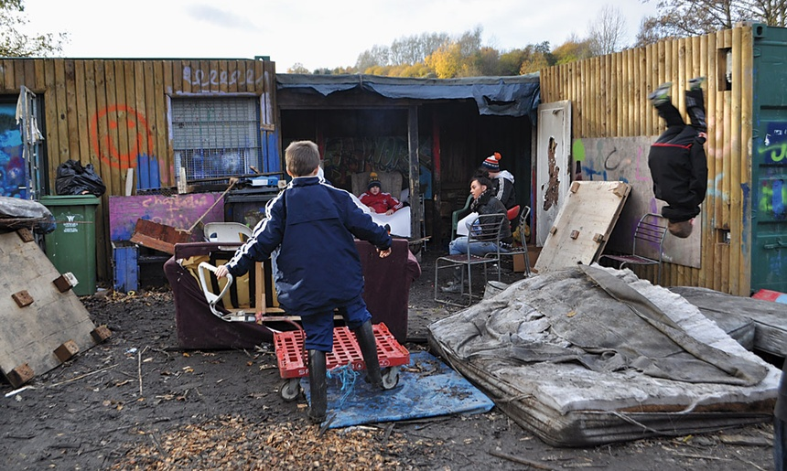Children have a sensory need to taste danger—to play near fire, experience heights, move at a speed that feels too fast. (Hanna Rosin)
Sandseter began observing and interviewing children on playgrounds in Norway. In 2011, she published her results in a paper called “Children’s Risky Play From an Evolutionary Perspective: The Anti-Phobic Effects of Thrilling Experiences.” Children, she concluded, have a sensory need to taste danger and excitement; this doesn’t mean that what they do has to actually be dangerous, only that they feel they are taking a great risk. That scares them, but then they overcome the fear. In the paper, Sandseter identifies six kinds of risky play: (1) Exploring heights, or getting the “bird’s perspective,” as she calls it—“high enough to evoke the sensation of fear.” (2) Handling dangerous tools—using sharp scissors or knives, or heavy hammers that at first seem unmanageable but that kids learn to master. (3) Being near dangerous elements—playing near vast bodies of water, or near a fire, so kids are aware that there is danger nearby. (4) Rough-and-tumble play—wrestling, play-fighting—so kids learn to negotiate aggression and cooperation. (5) Speed—cycling or skiing at a pace that feels too fast. (6) Exploring on one’s own.
This last one Sandseter describes as “the most important for the children.” She told me, “When they are left alone and can take full responsibility for their actions, and the consequences of their decisions, it’s a thrilling experience.”
To gauge the effects of losing these experiences, Sandseter turns to evolutionary psychology. Children are born with the instinct to take risks in play, because historically, learning to negotiate risk has been crucial to survival; in another era, they would have had to learn to run from some danger, defend themselves from others, be independent. Even today, growing up is a process of managing fears and learning to arrive at sound decisions. By engaging in risky play, children are effectively subjecting themselves to a form of exposure therapy, in which they force themselves to do the thing they’re afraid of in order to overcome their fear. But if they never go through that process, the fear can turn into a phobia. Paradoxically, Sandseter writes, “our fear of children being harmed,” mostly in minor ways, “may result in more fearful children and increased levels of psychopathology.” She cites a study showing that children who injured themselves falling from heights when they were between 5 and 9 years old are less likely to be afraid of heights at age 18. “Risky play with great heights will provide a desensitizing or habituating experience,” she writes.
related story

Let Kids Play With Fire
"We see a child climbing a tree and the first thing we think of is how they might fall and be maimed for life, when we might as easily say, 'Look at how well Sarah is climbing that tree!'"
Read the full May 2011 storyby Veronique Greenwood
We might accept a few more phobias in our children in exchange for fewer injuries. But the final irony is that our close attention to safety has not in fact made a tremendous difference in the number of accidents children have. According to the National Electronic Injury Surveillance System, which monitors hospital visits, the frequency of emergency-room visits related to playground equipment, including home equipment, in 1980 was 156,000, or one visit per 1,452 Americans. In 2012, it was 271,475, or one per 1,156 Americans. The number of deaths hasn’t changed much either. From 2001 through 2008, the Consumer Product Safety Commission reported 100 deaths associated with playground equipment—an average of 13 a year, or 10 fewer than were reported in 1980. Head injuries, runaway motorcycles, a fatal fall onto a rock—most of the horrors Sweeney and Frost described all those years ago turn out to be freakishly rare, unexpected tragedies that no amount of safety-proofing can prevent.
Even rubber surfacing doesn’t seem to have made much of a difference in the real world. David Ball, a professor of risk management at Middlesex University, analyzed U.K. injury statistics and found that as in the U.S., there was no clear trend over time. “The advent of all these special surfaces for playgrounds has contributed very little, if anything at all, to the safety of children,” he told me. Ball has found some evidence that long-bone injuries, which are far more common than head injuries, are actually increasing. The best theory for that is “risk compensation”—kids don’t worry as much about falling on rubber, so they’re not as careful, and end up hurting themselves more often. The problem, says Ball, is that “we have come to think of accidents as preventable and not a natural part of life.”
The category of risky play on Sandseter’s list that likely makes this current generation of parents most nervous is the one involving children getting lost, or straying from adult supervision. “Children love to walk off alone and go exploring away from the eyes of adults,” she writes. They “experience a feeling of risk and danger of getting lost” when “given the opportunity to ‘cruise’ on their own exploring unknown areas; still, they have an urge to do it.” Here again Sandseter cites evidence showing that the number of separation experiences before age 9 correlates negatively with separation-anxiety symptoms at age 18, “suggesting an ‘inoculation’ effect.”
In all my years as a parent, I’ve mostly met children who take it for granted that they are always being watched.
But parents these days have little tolerance for children’s wandering on their own, for reasons that, much like the growing fear of playground injuries, have their roots in the 1970s. In 1979, nine months after Frank Nelson fell off that slide in Chicago, 6-year-old Etan Patz left his parents’ downtown New York apartment to walk by himself to the school-bus stop. Etan had been begging his mother to let him walk by himself; many of his friends did, and that morning was the first time she let him. But, as just about anyone who grew up in New York in that era knows, he never came home. (In 2012, a New Jersey man was arrested for Etan’s murder.) I was nearly 10 at the time, and I remember watching the nightly news and seeing his school picture, with a smile almost as wide as Mick Jagger’s. I also remember that, sometime during those weeks of endless coverage of the search for Etan, the parents in my neighborhood for the first time organized a walk pool to take us to the bus stop.
The Etan Patz case launched the era of the ubiquitous missing child, as Paula Fass chronicles in Kidnapped: Child Abduction in America. Children’s faces began to appear on milk cartons, and Ronald Reagan chose the date of Etan’s disappearance as National Missing Children’s Day. Although no one knew what had happened to Etan, a theory developed that he had been sexually abused; soon The New York Times quoted a psychologist who said that the Patz case heralded an “epidemic of sexual abuse of children.” In a short period, writes Fass, Americans came to think child molestations were very prevalent. Over time, the fear drove a new parenting absolute: children were never to talk to strangers.
But abduction cases like Etan Patz’s were incredibly uncommon a generation ago, and remain so today. David Finkelhor is the director of the Crimes Against Children Research Center and the most reliable authority on sexual-abuse and abduction statistics for children. In his research, Finkelhor singles out a category of crime called the “stereotypical abduction,” by which he means the kind of abduction that’s likely to make the news, during which the victim disappears overnight, or is taken more than 50 miles away, or is killed. Finkelhor says these cases remain exceedingly rare and do not appear to have increased since at least the mid-’80s, and he guesses the ’70s, although he was not keeping track then. Overall, crimes against children have been declining, in keeping with the general crime drop since the ’90s. A child from a happy, intact family who walks to the bus stop and never comes home is still a singular tragedy, not a national epidemic.
One kind of crime that has increased, says Finkelhor, is family abduction (which is lumped together with stereotypical abduction in FBI crime reports, accounting for the seemingly alarming numbers sometimes reported in the media). The explosion in divorce in the ’70s meant many more custody wars and many more children being smuggled away by one or the other of their parents. If a mother is afraid that her child might be abducted, her ironclad rule should not be Don’t talk to strangers. It should beDon’t talk to your father.
The gap between what people fear (abduction by a stranger) and what’s actually happening (family turmoil and custody battles) is revealing. What has changed since the 1970s is the nature of the American family, and the broader sense of community. For a variety of reasons—divorce, more single-parent families, more mothers working—both families and neighborhoods have lost some of their cohesion. It is perhaps natural that trust in general has eroded, and that parents have sought to control more closely what they can—most of all, their children.
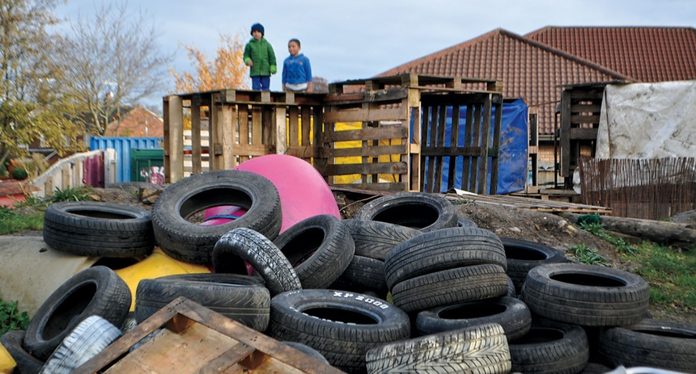In contrast with many American playgrounds, children tend to arrive at the Land unaccompanied by their parents. (Hanna Rosin)
As we parents began to see public spaces—playgrounds, streets, public ball fields, the distance between school and home—as dangerous, other, smaller daily decisions fell into place. Ask any of my parenting peers to chronicle a typical week in their child’s life and they will likely mention school, homework, after-school classes, organized playdates, sports teams coached by a fellow parent, and very little free, unsupervised time. Failure to supervise has become, in fact, synonymous with failure to parent. The result is a “continuous and ultimately dramatic decline in children’s opportunities to play and explore in their own chosen ways,” writes Peter Gray, a psychologist at Boston College and the author of Free to Learn. No more pickup games, idle walks home from school, or cops and robbers in the garage all afternoon. The child culture from my Queens days, with its own traditions and codas, its particular pleasures and distresses, is virtually extinct.
In 1972, the British-born geography student Roger Hart settled on an unusual project for his dissertation. He moved to a rural New England town and, for two years, tracked the movements of 86 children in the local elementary school, to create what he called a “geography of children,” including actual maps that would show where and how far the children typically roamed away from home. Usually research on children is conducted by interviewing parents, but Hart decided he would go straight to the source. The principal of the school lent him a room, which became known as “Roger’s room,” and he slowly got to know the children. Hart asked them questions about where they went each day and how they felt about those places, but mostly he just wandered around with them. Even now, as a father and a settled academic, Hart has a dreamy, puckish air. Children were comfortable with him and loved to share their moments of pride, their secrets. Often they took him to places adults had never seen before—playhouses or forts the kids had made just for themselves.
Hart’s methodology was novel, but he didn’t think he was recording anything radical. Many of his observations must have seemed mundane at the time. For example: “I was struck by the large amount of time children spend modifying the landscape in order to make places for themselves and for their play.” But reading his dissertation today feels like coming upon a lost civilization, a child culture with its own ways of playing and thinking and feeling that seems utterly foreign now. The children spent immense amounts of time on their own, creating imaginary landscapes their parents sometimes knew nothing about. The parents played no role in their coming together—“it is through cycling around that the older boys chance to fall into games with each other,” Hart observed. The forts they built were not praised and cooed over by their parents, because their parents almost never saw them.
“There’s a fear” among parents, Roger Hart told me, “an exaggeration of the dangers, a loss of trust” that isn’t clearly explainable.
Through his maps, Hart discovered broad patterns: between second and third grade, for instance, the children’s “free range”—the distance they were allowed to travel away from home without checking in first—tended to expand significantly, because they were permitted to ride bikes alone to a friend’s house or to a ball field. By fifth grade, the boys especially gained a “dramatic new freedom” and could go pretty much wherever they wanted without checking in at all. (The girls were more restricted because they often helped their mothers with chores or errands, or stayed behind to look after younger siblings.) To the children, each little addition to their free range—being allowed to cross a paved road, or go to the center of town—was a sign of growing up. The kids took special pride, Hart noted, in “knowing how to get places,” and in finding shortcuts that adults wouldn’t normally use.
Hart’s research became the basis for a BBC documentary, which he recently showed me in his office at the City University of New York. One long scene takes place across a river where the kids would go to build what they called “river houses,” structures made from branches and odds and ends they’d snuck out from home. In one scene, Joanne and her sister Sylvia show the filmmakers the “house” they made, mostly from orange and brown sheets slung over branches. The furniture has been built with love and wit—the TV, for example, is a crate on a rock with a magazine glamour shot taped onto the front. The phone is a stone with a curled piece of wire coming out from under it.
The girls should be self-conscious because they are being filmed, but they are utterly at home, flipping their hair, sitting close to each other on crates, and drawing up plans for how to renovate. Nearby, their 4-year-old brother is cutting down a small tree with a hatchet for a new addition. The girls and their siblings have logged hundreds of hours here over the years; their mother has never been here, not once, they say, because she doesn’t like to get her toes wet.
In another scene, Andrew and Jenny, a brother and sister who are 6 and 4, respectively, explore a patch of woods to find the best ferns to make a bed with. Jenny walks around in her knee-high white socks, her braids swinging, looking for the biggest fronds. Her big brother tries to arrange them just so. The sun is shining through the dense trees and the camera stays on the children for a long time. When they are satisfied with their bed, they lie down next to each other. “Don’t take any of my ferns,” Jenny scolds, and Andrew sticks his tongue out. At this point, I could hear in my head the parent intervening: “Come on, kids, share. There’s plenty to go around.” But no parents are there; the kids have been out of their sight for several hours now. I teared up while watching the film, and it was only a few days later that I understood why. In all my years as a parent, I have never come upon children who are so inwardly focused, so in tune with each other, so utterly absorbed by the world they’ve created, and I think that’s because in all my years as a parent, I’ve mostly met children who take it for granted that they are always being watched.
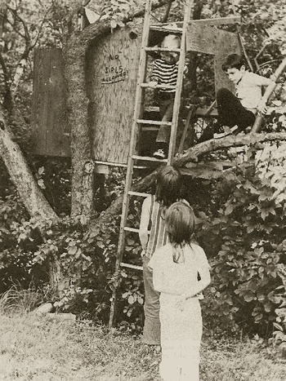The children studied by Roger Hart in the 1970s spent much of their free time out of sight of parents, in secret places all their own. (Roger Hart)
In 2004, Hart returned to the same town to do a follow-up study. His aim was to reconnect with any kids he had written about who still lived within 100 miles of the town and see how they were raising their own children, and also to track some of the kids who now lived in the town. But from the first day he arrived, he knew he would never be able to do the research in the same way. Hart started at the house of a boy he’d known, now a father, and asked whether he could talk to his son outside. The mother said they could go in the backyard, but she followed them, always staying about 200 yards behind them. Hart didn’t get the sense that the parents were suspicious of him, more that they’d “gotten used to the idea of always being close to their children, and didn’t like them going off.” He realized that this time around, he could get to the children only through the adults; even the kids didn’t seem that interested in talking to him alone; they got plenty of adult attention already. “They were so used to having their lives organized by their parents,” he told me. Meanwhile, the new principal at the school said he didn’t want Hart doing any research there, because it was not directly related to the curriculum.
At one point Hart tracked down Sylvia, one of the girls he’d filmed at the river house. “Roger Hart! Oh my God, my childhood existed,” she screamed into the phone. “It’s just that I’m always telling people what we used to do, and they don’t believe me!” Sylvia was now a suburban mom of two kids (ages 5 and 4), and she and her husband had moved into a new house 30 miles away. When Hart went to visit Sylvia, he filmed the exchange. Standing outside in her backyard, Sylvia tells him she bought this house because she wanted to give her own children the kinds of childhood experiences she’d had, and when she saw the little wooded area out back, her “heart leapt.” But “there’s no way they’d be out in the woods,” she adds. “My hometown is now so diverse, with people coming in and out and lots of transients.” Hart reminds her how she used to spend most of her time across the river, playing. “There’s no river here,” she tells him, then whispers, “and I’m really glad about that.” There will soon be a fence around the yard—she mentions the fence several times—“so they’ll be contained,” and she’ll always be able to see her kids from the kitchen window. As Sylvia is being interviewed, her son makes some halfhearted attempts to cut the hedges with a pair of scissors, but he doesn’t really seem to know how to do it, and he never strays more than a few inches from his father.
When Hart shows Jenny and Andrew the film of themselves playing in the ferns, they are both deeply moved, because they’d never seen a film of themselves as children, and because for them, too, the memories had receded into hazy unreality. They are both parents and are still living in that New England town. Of all the people Hart caught up with, they seem to have tried the hardest to create some of the same recreational opportunities for their own children that they’d had. Jenny bought a house, with a barn, near a large patch of woods; she doesn’t let her sons watch TV or play video games all that much, instead encouraging them to go to the barn and play in the hay, or tend the garden. She says she wouldn’t really mind if they strayed into the woods, but “they don’t want to go out of sight.” Anyway, they get their exercise from the various sports teams they play on. Jenny gets some of her girlish self back when she talks about how she and the boys pile up rocks in the backyard to build a ski jump or use sticks to make a fort. But Jenny initiates these activities; the boys usually don’t discover them on their own.
Among this new set of kids, the free range is fairly limited. They don’t roam all that far from home, and they don’t seem to want to. Hart talked with a law-enforcement officer in the area, who said that there weren’t all that many transients and that over the years, crime has stayed pretty steady—steadily low. “There’s a fear” among the parents, Hart told me, “an exaggeration of the dangers, a loss of trust that isn’t totally clearly explainable.” Hart hasn’t yet published his findings from his more recent research, and he told me he’s wary of running into his own nostalgia for the Rousseauean children of his memories. For example, he said he has to be honest about the things that have improved in the new version of childhood. In the old days, when children were left on their own, child power hierarchies formed fairly quickly, and some children always remained on the bottom, or were excluded entirely. Also, fathers were largely absent; now children are much closer to their dads—closer to both their parents than kids were back then. I would add that the 1970s was the decade of the divorce boom, and many children felt neglected by their parents; perhaps today’s close supervision is part of a vow not to repeat that mistake. And yet despite all this, Hart can’t help but wonder what disappeared with “the erosion of child culture,” in which children were “inventing their own activities and building up a kind of community of their own that they knew much more about than their parents.”
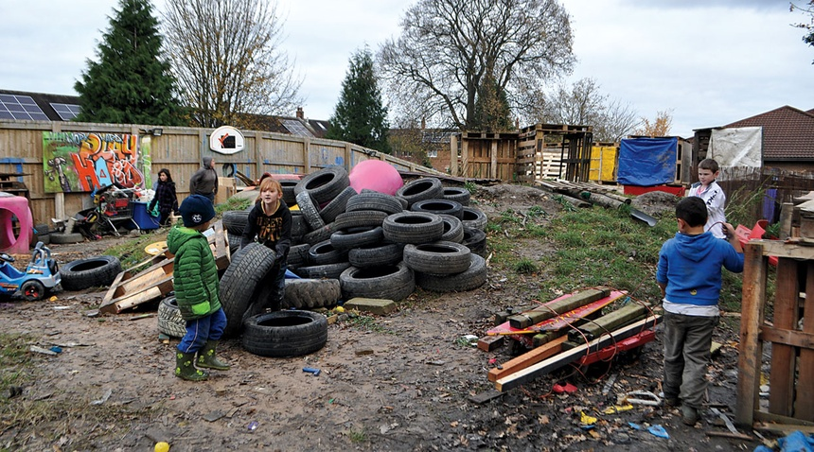At the Land playground, adult “playworkers” watch over the children, but rarely intervene. (Hanna Rosin)
One common concern of parents these days is that children grow up too fast. But sometimes it seems as if children don’t get the space to grow up at all; they just become adept at mimicking the habits of adulthood. As Hart’s research shows, children used to gradually take on responsibilities, year by year. They crossed the road, went to the store; eventually some of them got small neighborhood jobs. Their pride was wrapped up in competence and independence, which grew as they tried and mastered activities they hadn’t known how to do the previous year. But these days, middle-class children, at least, skip these milestones. They spend a lot of time in the company of adults, so they can talk and think like them, but they never build up the confidence to be truly independent and self-reliant.
Lately parents have come to think along the class lines defined by the University of Pennsylvania sociologist Annette Lareau. Middle-class parents see their children as projects: they engage in what she calls “concerted cultivation,” an active pursuit of their child’s enrichment. Working-class and poor parents, meanwhile, speak fewer words to their children, watch their progress less closely, and promote what Lareau calls the “accomplishment of natural growth,” perhaps leaving the children less prepared to lead middle-class lives as adults. Many people interpret her findings as proof that middle-class parenting styles, in their totality, are superior. But this may be an overly simplistic and self-serving conclusion; perhaps each form of child-rearing has something to recommend it to the other.
When Claire Griffiths, the Land’s manager, applies for grants to fund her innovative play spaces, she often lists the concrete advantages of enticing children outside: combatting obesity, developing motor skills. She also talks about the same issue Lady Allen talked about all those years ago—encouraging children to take risks so they build their confidence. But the more nebulous benefits of a freer child culture are harder to explain in a grant application, even though experiments bear them out. For example, beginning in 2011, Swanson Primary School in New Zealand submitted itself to a university experiment and agreed to suspend all playground rules, allowing the kids to run, climb trees, slide down a muddy hill, jump off swings, and play in a “loose-parts pit” that was like a mini adventure playground. The teachers feared chaos, but in fact what they got was less naughtiness and bullying—because the kids were too busy and engaged to want to cause trouble, the principal said.
In an essay called “The Play Deficit,” Peter Gray, the Boston College psychologist, chronicles the fallout from the loss of the old childhood culture, and it’s a familiar list of the usual ills attributed to Millennials: depression, narcissism, and a decline in empathy. In the past decade, the percentage of college-age kids taking psychiatric medication has spiked, according to a 2012 study by the American College Counseling Association. Practicing psychologists have written (in this magazine and others) about the unique identity crisis this generation faces—a fear of growing up and, in the words of Brooke Donatone, a New York–based therapist, an inability “to think for themselves.”
In his essay, Gray highlights the work of Kyung-Hee Kim, an educational psychologist at the College of William and Mary and the author of the 2011 paper “The Creativity Crisis.” Kim has analyzed results from the Torrance Tests of Creative Thinking and found that American children’s scores have declined steadily across the past decade or more. The data show that children have become: less emotionally expressive, less energetic, less talkative and verbally expressive, less humorous, less imaginative, less unconventional, less lively and passionate, less perceptive, less apt to connect seemingly irrelevant things, less synthesizing, and less likely to see things from a different angle.
The largest drop, Kim noted, has been in the measure of “elaboration,” or the ability to take an idea and expand on it in a novel way.
The stereotypes about Millennials have alarmed researchers and parents enough that they’ve started pushing back against the culture of parental control. Many recent parenting books have called for a retreat, among them Duct Tape Parenting, Baby Knows Best, and the upcoming The Kids Will Be Fine. In her excellent new book, All Joy and No Fun, Jennifer Senior takes the route that parents are making themselves miserable by believing they always have to maximize their children’s happiness and success.
In the U.K., the safety paranoia is easing up. The British equivalent of the Consumer Product Safety Commission recently released a statement saying it “wants to make sure that mistaken health and safety concerns do not create sterile play environments that lack challenge and so prevent children from expanding their learning and stretching their abilities.” When I was in the U.K., Tim Gill, the author of No Fear, took me to a newly built London playground that reminded me of the old days, with long, fast slides down a rocky hill, high drops from a climbing rock, and few fenced-in areas. Meanwhile, the Welsh government has explicitly adopted a strategy to encourage active independent play, rather than book learning, among young children, paving the way for a handful of adventure playgrounds like the Land and other play initiatives.
If a mother is afraid that her child might be abducted, her ironclad rule should not be Don’t talk to strangers. It should be Don’t talk to your father. Whether Americans will pick up on the British vibe is hard to say, although some hopeful signs are appearing. There is rising American interest in European-style “forest kindergartens,” where kids receive little formal instruction and have more freedom to explore in nature. And in Washington, D.C., not far from where I live, we finally have our first exciting playground since the “forgotten playground” was leveled. Located at a private school called Beauvoir, it has a zip line and climbing structures that kids of all ages perceive as treacherous. I recently met someone who worked on the playground and asked him why the school board wasn’t put off by safety concerns, especially since it keeps the park open to the public on weekends. He said the board was concerned about safety but also wanted an exciting playground; the safety guidelines are, after all these years, still just guidelines. But the real cultural shift has to come from parents. There is a big difference between avoiding major hazards and making every decision with the primary goal of optimizing child safety (or enrichment, or happiness). We can no more create the perfect environment for our children than we can create perfect children. To believe otherwise is a delusion, and a harmful one; remind yourself of that every time the panic rises.
As the sun set over the Land, I noticed out of the corner of my eye a gray bin, like the kind you’d keep your recycling in, about to be pushed down the slope that led to the creek. A kid’s head poked out of the top, and I realized it was my son’s. Even by my relatively laissez-faire parenting standards, the situation seemed dicey. The light was fading, the slope was very steep, and Christian, the kid who was doing the pushing, was only 7. Also, the creek was frigid, and I had no change of clothes for Gideon.
I hadn’t seen much of my son that day. Kids, unparented, take on pack habits, so as the youngest and newest player, he’d been taken care of by the veterans of the Land. I inched close enough to hear the exchange. “You might fall in the creek,” said Christian. “I know,” said Gideon.Christian had already taught Gideon how to climb up to the highest slide and manage the rope swing. At this point, he’d earned some trust. “I’ll push you gently, okay?” “Ready, steady, go!,” Gideon said in response. Down he went, and landed in the creek. In my experience, Gideon is very finicky about water. He hates to have even a drop land on his sleeve while he’s brushing his teeth. I hadn’t rented a car on this trip, and the woman who’d been driving us around had left for a while. I started scheming how to get him new clothes. Could I knock on one of the neighbors’ doors? Ask Christian to get his father? Or, failing that, persuade Gideon to sit a while with the big boys by the fire?
“I’m wet,” Gideon said to Christian, and then they raced over to claim some hammers to build a new fort.

